In canvas mode hide connection parts
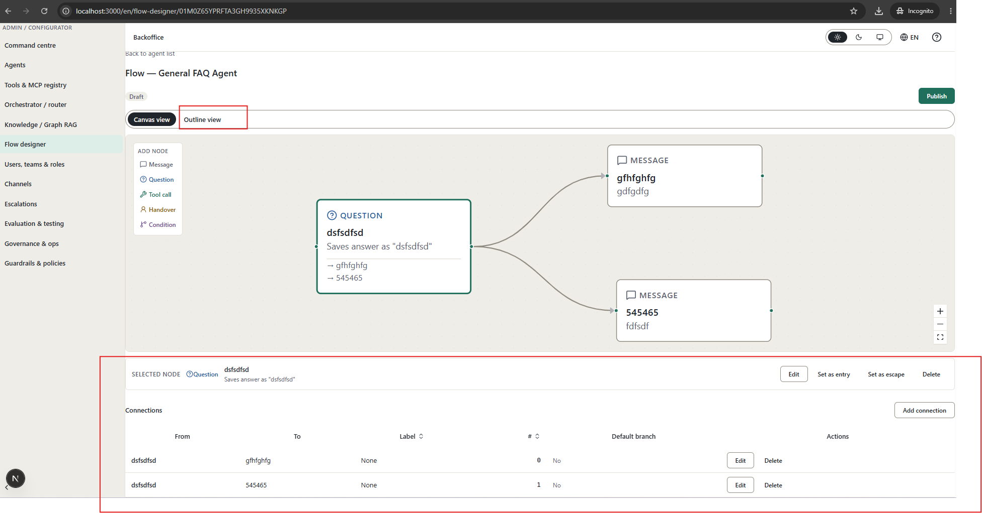
Remove flow designer from menu
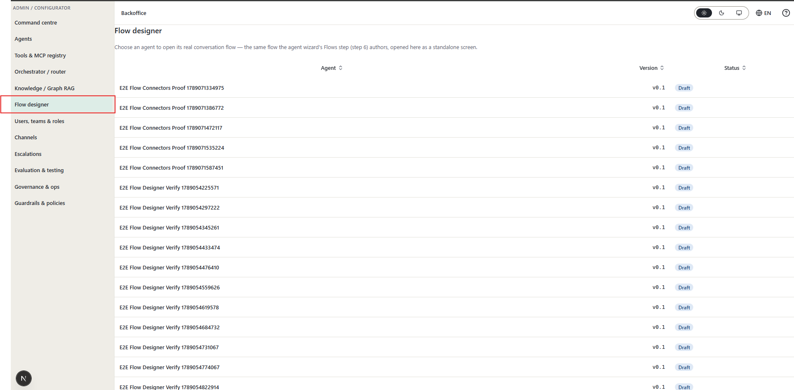

No method to connect knowledge
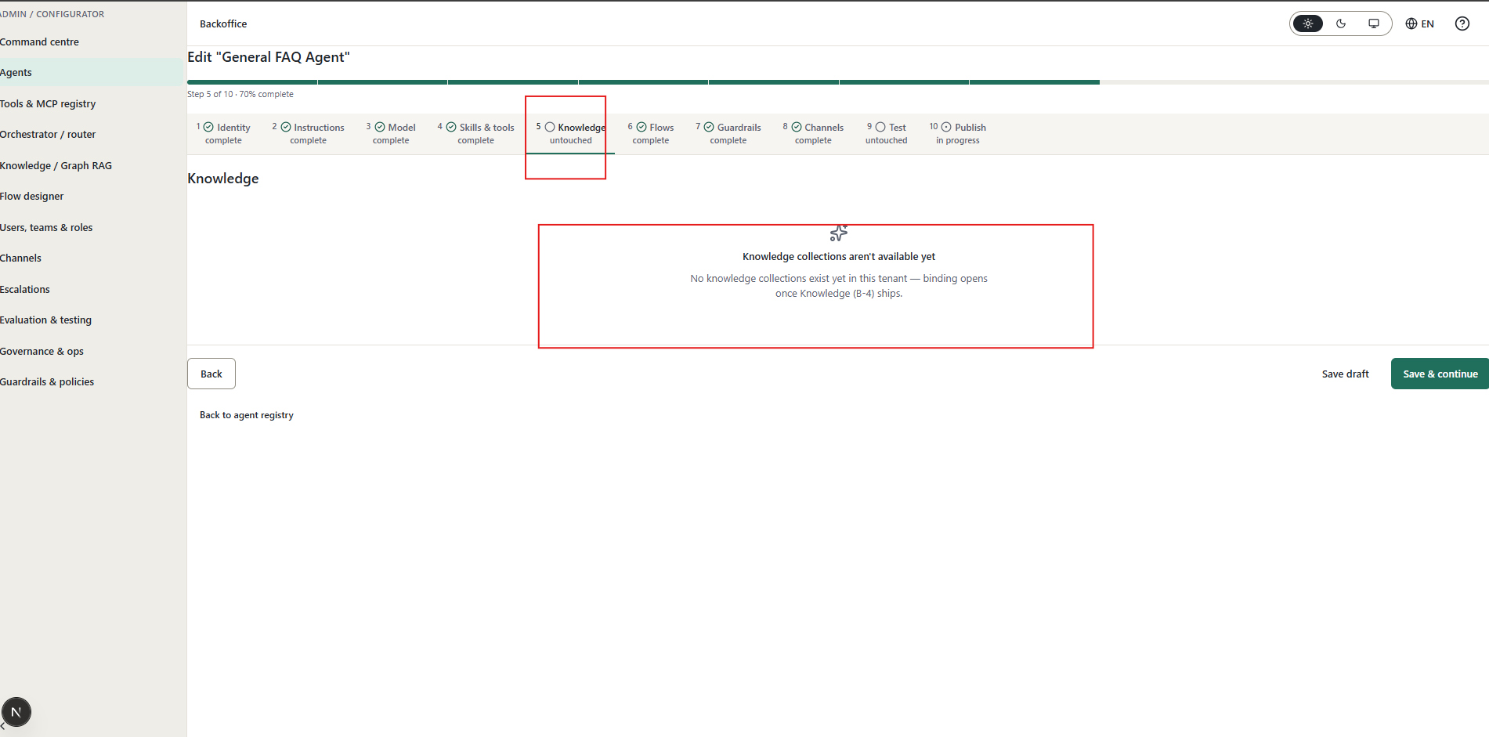
Remove header since not needed in the below screen
Remove publish and link with agent publish function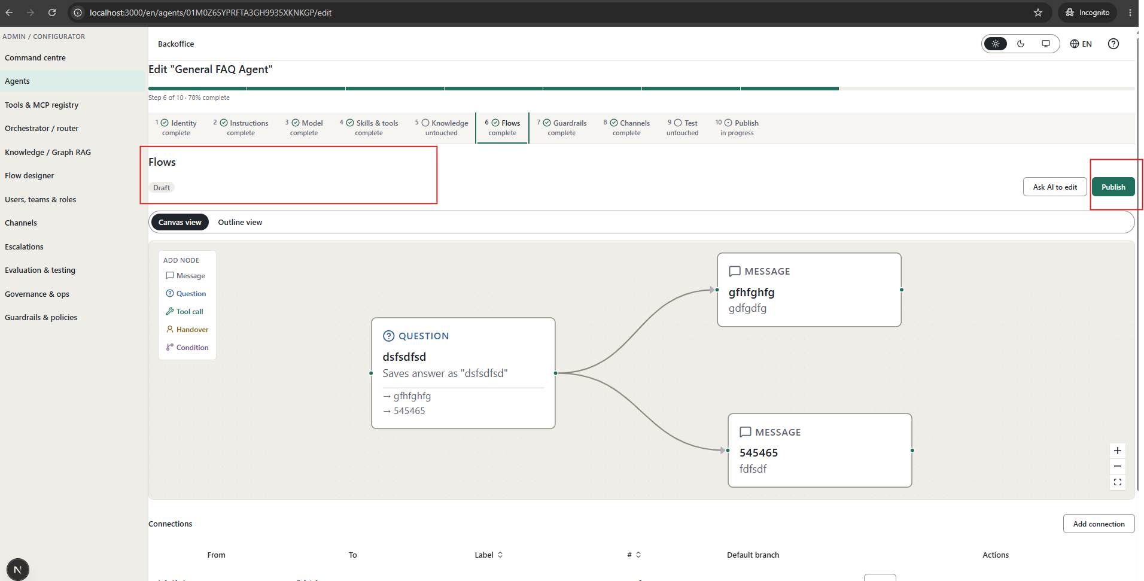

Flow nodes are hard to maintain make it more example (avoid any json , avoid any advanced technical required input)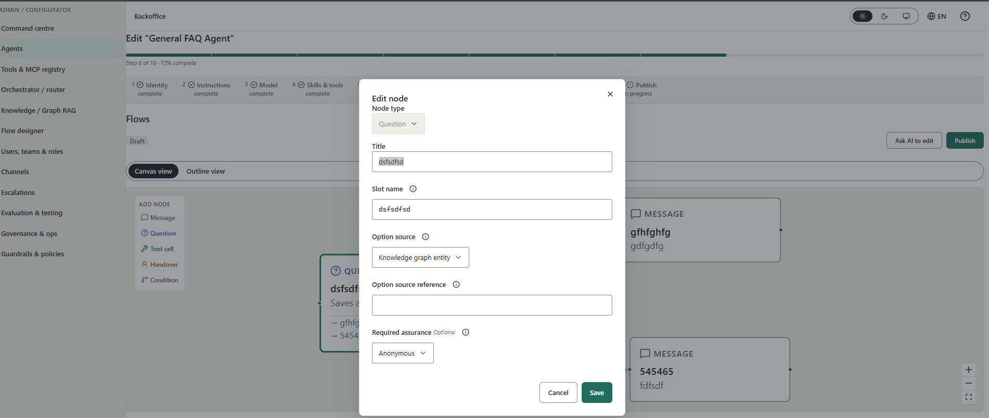
Sandbox testing not working
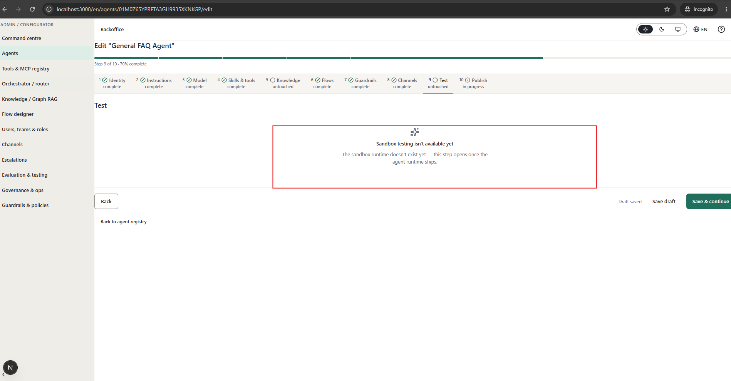

Knoledg grapgh not working
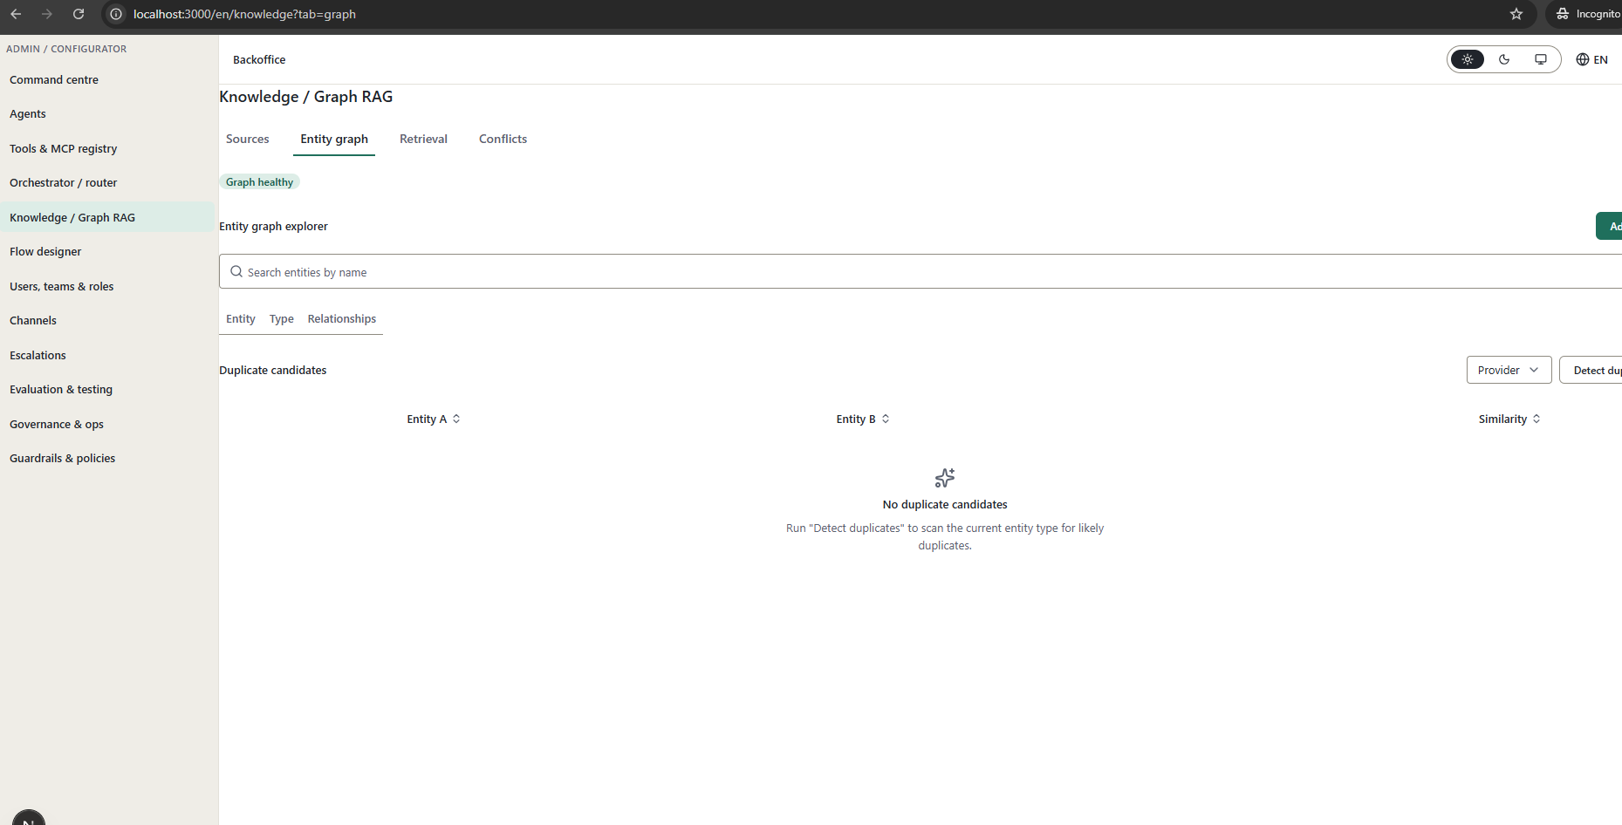
Knowledge retrieval screen not user friendly
